Name : Maaz qureshi ID : 21904531
Group : 02

Task 4 : #include <stdlib.h>
#include <sys/types.h>
#include <stdio.h>
#include <unistd.h>

#define MAX_COUNT 2

void FunctionCalledByChild(void);
void FunctionCalledByParent(void);

void main(void)
{
pid_t pid;

// Create a child process
pid = fork();

if (pid < 0) // Error in forking
{
fprintf(stderr, "Fork failed\n");
exit(1);
}
else if (pid == 0) // Child process
{
FunctionCalledByChild();
}
else // Parent process
{
FunctionCalledByParent();
}
}

void FunctionCalledByChild(void)
{
int i;
for (i = 1; i <= MAX_COUNT; i++)
printf("This is printed by Child\n");
printf("*** Child process completed ***\n");
}

void FunctionCalledByParent(void)
{
int i;
for (i = 1; i <= MAX_COUNT; i++)
printf("This is printed by Parent\n");
printf("*** Parent is completed ***\n");
}

Answer :
- Run this program 3 times and write the results for each run. Is there any difference in the results? Explain your answer.
Yes, the results may vary between different runs because the child and parent processes execute concurrently.

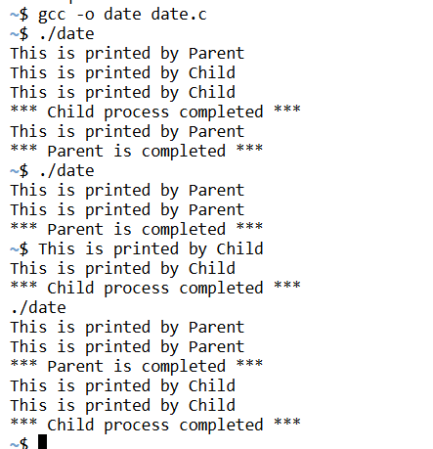

3 : Repeat Step 2 by changing MAX_COUNT to 25

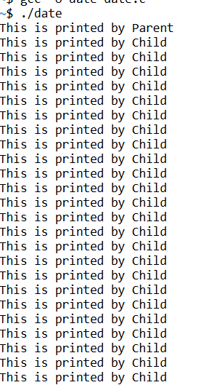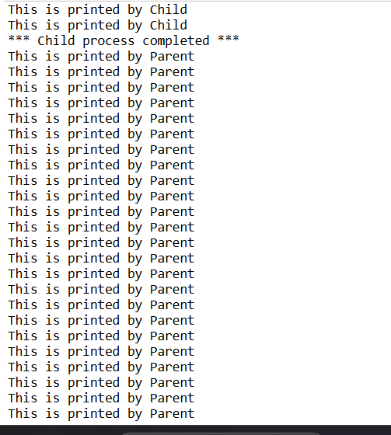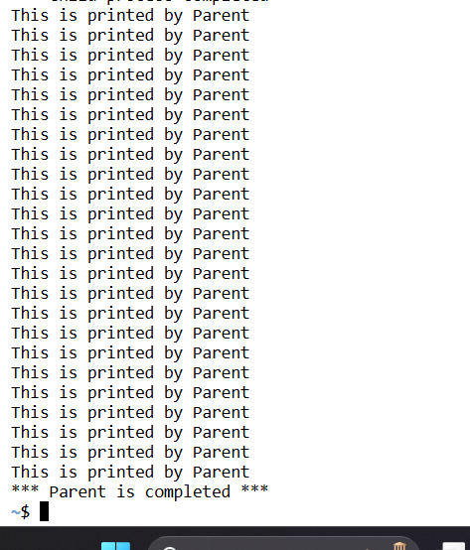

Task 1 :
/* fork1.c */
#include <stdio.h>
#include <stdlib.h>
#include <sys/types.h>
#include <unistd.h>

int main()
{
int i;
pid_t pid;
printf("Message A by %d \n", getpid());

pid = fork();
if (pid == -1)
{
perror("fork");
exit(1);
}

printf("Message B by %d \n", getpid());
printf("Message C by %d \n", getpid());

exit(0);
}
~$ gcc -o date date.c
~$ ./date
Message A by 978
Message B by 978
Message C by 978
Message B by 979
Message C by 979
~$ ./date
Message A by 980
Message B by 980
Message C by 980
Message B by 981
Message C by 981
~$ ./date
Message A by 982
Message B by 982
Message C by 982
Message B by 983
Message C by 983

Task 2 :

/* fork1.c */
#include <stdio.h>
#include <stdlib.h>
#include <sys/types.h>
#include <unistd.h>

int main()
{
int i;
pid_t pid;

printf("Message A by %d \n", getpid());

pid = fork();
if (pid == -1)
{
perror("fork");
exit(1);
}
else if (pid == 0)
{
printf("Message B by %d \n", getpid());
}
else
{
printf("Message C by %d \n", getpid());
}

exit(0);
}

Answer :
~$ ./date
Message A by 816
Message C by 816
Message B by 817
~$ ./date
Message A by 818
Message C by 818
Message B by 819
~$ ./date
Message A by 820
Message C by 820
Message B by 821

Task 3 :

/* fork2.c */
#include <stdio.h>
#include <stdlib.h>
#include <sys/types.h>
#include <unistd.h>
#include <sys/wait.h>

int main()
{
int i;
pid_t pid;

printf("Message A by %d \n", getpid());

pid = fork();
if (pid == -1)
{
perror("fork");
exit(1);
}

if (pid == 0) // Child process
{
printf("Child process ID: %d \n", getpid());
printf("Parent process ID: %d \n", getppid());

for (i = 0; i < 5; i++)
{
printf("Child: Message B\n");
sleep(1);
}

printf("Child process terminating.\n");
exit(0);
}

// Parent process
printf("My ID: %d \n", getpid());

for (i = 0; i < 5; i++)
{
printf("Parent: Message C\n");
sleep(1);
}

printf("Parent process waiting for child.\n");
wait(NULL); // Ensures the parent waits for the child to finish

printf("Parent process terminating.\n");
exit(0);
}

Answer :
~$ gcc -o date date.c
~$ ./date
Message A by 1070
My ID: 1070
Parent: Message C
Child process ID: 1071
Parent process ID: 1070
Child: Message B
Parent: Message C
Child: Message B
Parent: Message C
Child: Message B
Child: Message B
Parent: Message C
Child: Message B
Parent: Message C
Child process terminating.
Parent process waiting for child.
Parent process terminating.

